M.PAVAN KUMAR 192312142
NANO ELECTRONICS ECA3101

Exp. 10. Biosensor and Bio-FET characteristics using NanoHub.
AIM:
1. To simulate the threshold voltage of a BioFET-based biosensor as a function of electrolyte pH (4 to 8).
2. To analyze the transfer characteristics (IdsI_{ds}Ids vs. VfgV_{fg}Vfg ) of the BioFET for varying pH levels and interpret the sensor's performance. 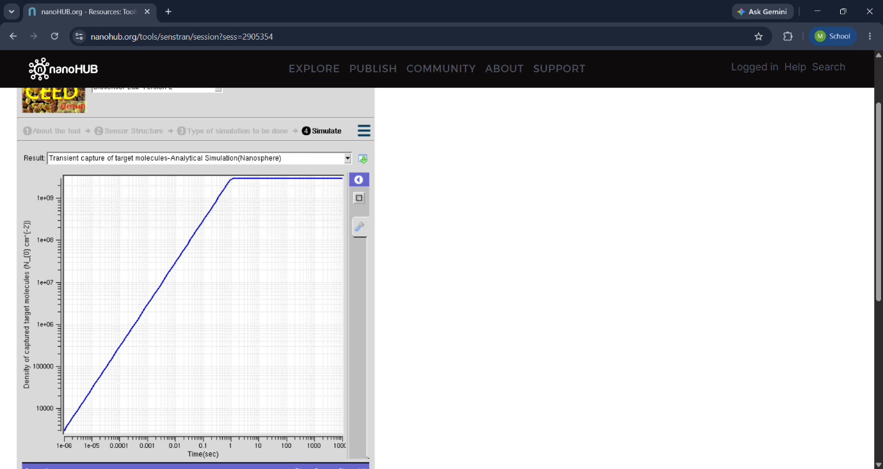
Image 1 – Bio-FET Structure
Impact: The image clearly shows the basic structure of the Bio-FET and helps in understanding how the biological sensing layer interacts with the transistor.

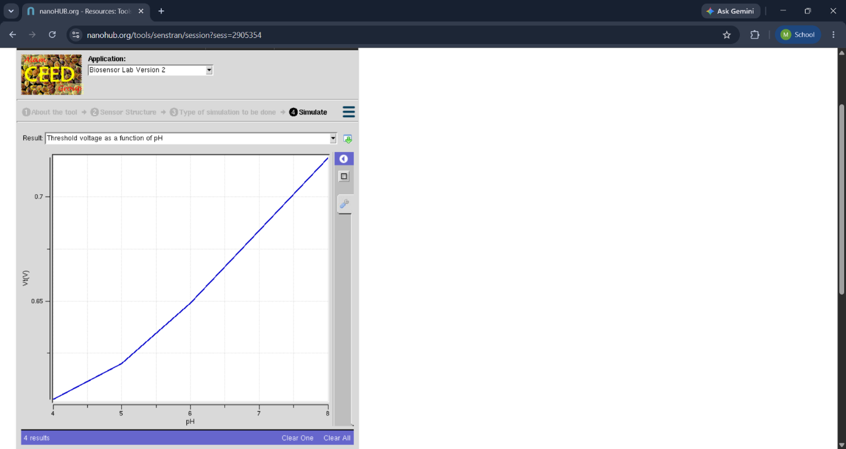
Image 2 – Input/Output Characteristics
Impact: The characteristic graph shows the relationship between voltage and drain current. It helps analyze the electrical behavior and sensitivity of the Bio-FET.

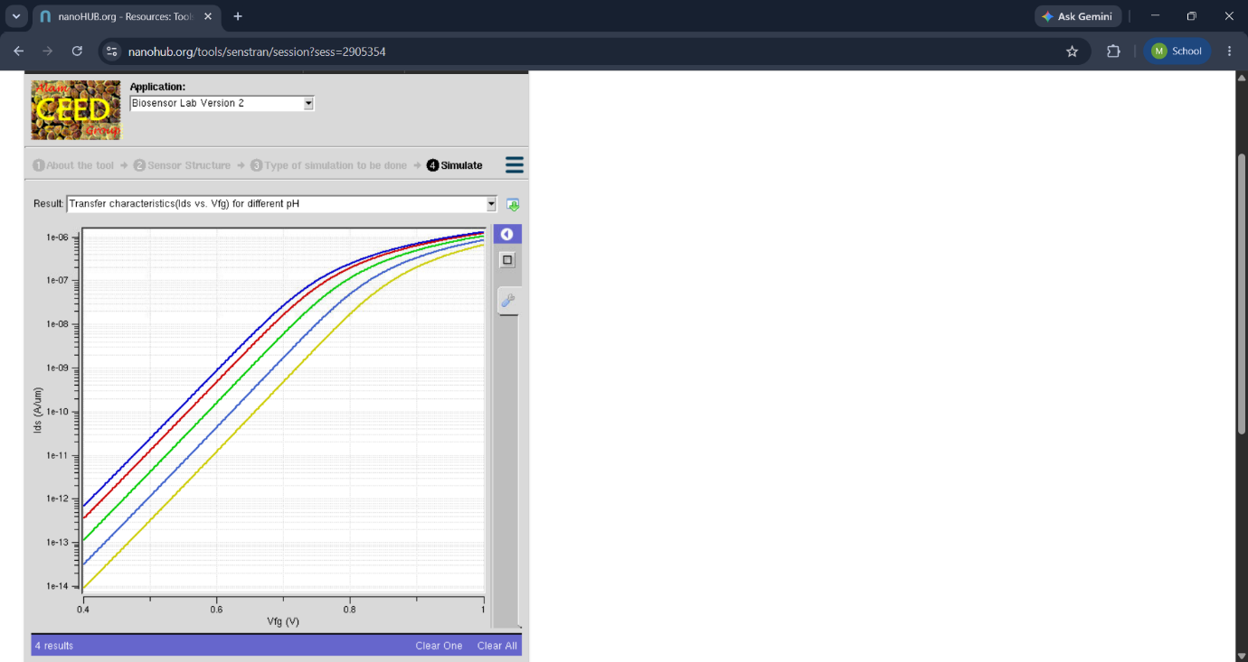
Image 3 – Biosensor Response
Impact: The graph demonstrates the change in electrical response due to the presence or concentration of biomolecules. It helps evaluate the sensing performance and detection capability of the biosensor.
Conclusion:The Biosensor and Bio-FET characteristics were successfully studied using NanoHub simulations. The obtained images and characteristic curves helped in understanding the electrical behavior and sensing mechanism of the Bio-FET.
Exp. 11. Calculate the Potential of a pH SENSOR using NanoHub
Aim:
To obtain the Potential of a sensor by varying the pH value of an electrolyte and insulator thickness.
CASE STUDY-1: semiconductor/insulator/electrolyte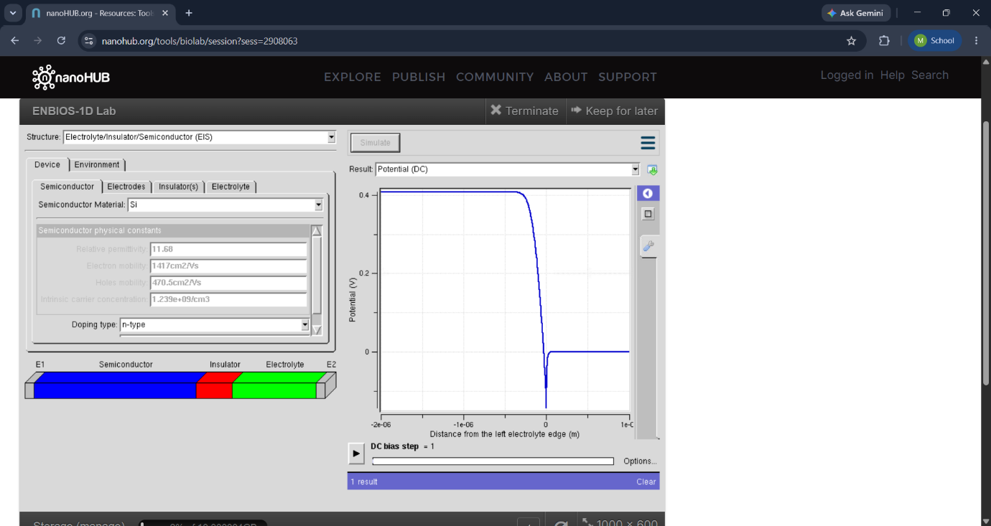
Image 1 – pH Sensor Structure
Impact: The image shows the basic structure of the pH sensor and helps understand how the sensing surface interacts with hydrogen ions (H⁺) in the solution.

Case study-2: electrolyte 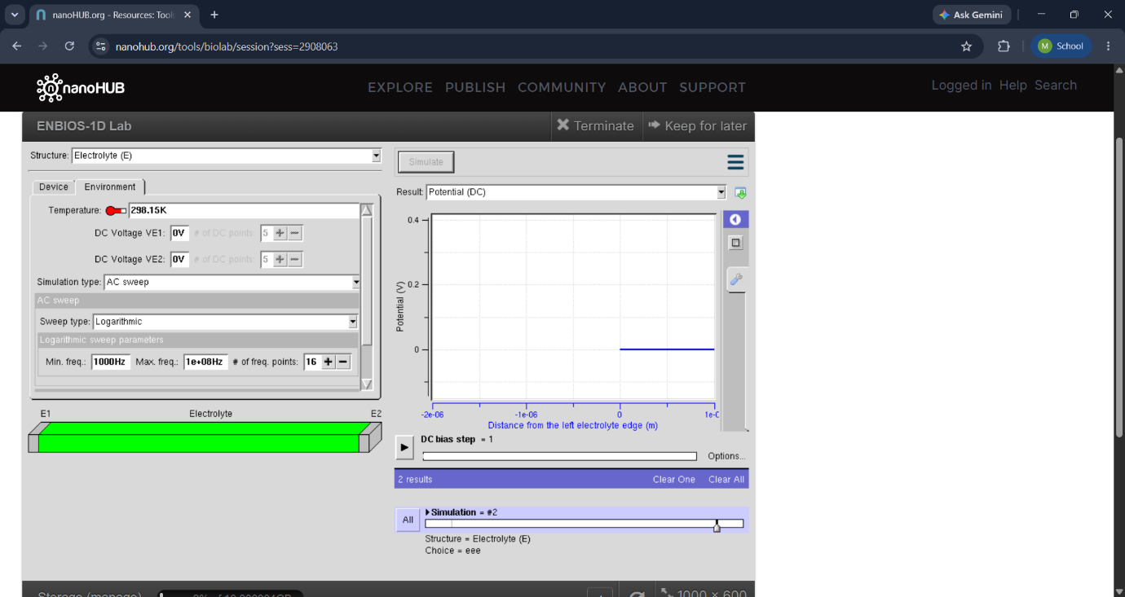
Image 2 – pH vs. Sensor Potential
Impact: The graph shows the variation of sensor potential with pH. It helps identify the sensor response and demonstrates how the potential changes when the pH of the solution changes.

Case study -3: Insulator
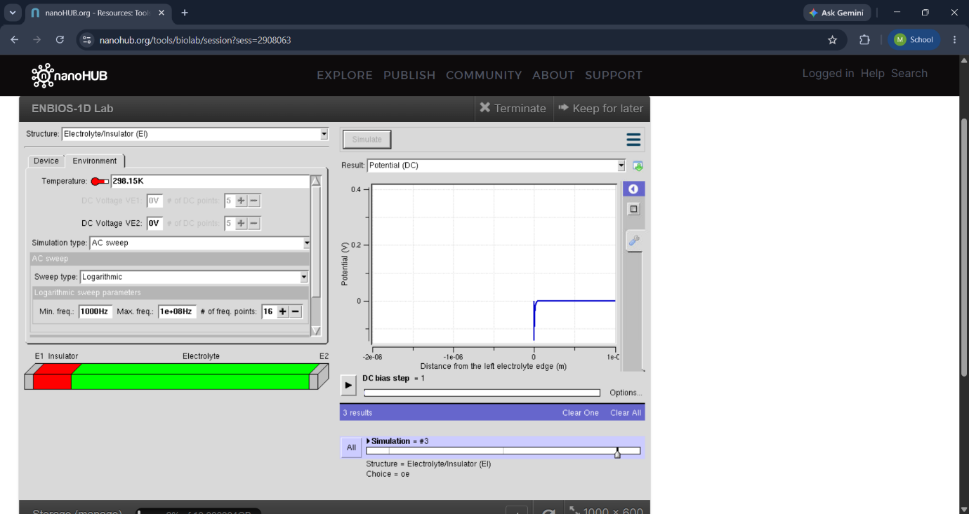
Image 3 – NanoHub Simulation Result
Impact: The simulation image provides the calculated potential for different pH values. It helps verify the theoretical behavior of the pH sensor and evaluate its sensitivity.
Conclusion
The potential of a pH sensor was successfully calculated and analyzed using NanoHub. The simulation results showed that the sensor potential changes with the pH of the solution, demonstrating the sensing mechanism of the device. The obtained graphs and images helped in understanding the relationship between pH and sensor potential and evaluating the sensitivity of the pH sensor.

